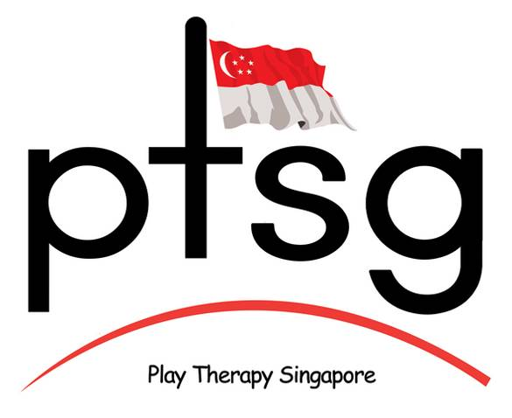 | Play Therapy International | www 9/15
 | Application Form for Membership | www 9/15

Your contact details:
Full name:
Address (please use your country’s address format if different):
Organisation (if applicable)

Building/number/street

City/Town

State/County

Postcode/Zipcode

Country

 |  |  | Country Code | STD/Area Code |  | Number
Telephones (Home)

(Office)

(Mobile)

(Fax)

Email Address
Grade applied for: (please circle one only) | Trainee | Practitioner | Full Member - Certified |  | Full Member - Accredited |  | Associate Member | PTI Certified Supervisor (if not already a full member) | Approved Supervisor
Grade applied for: (please circle one only) | SG$120 | SG$270 | SG$300 |  | SG$320 |  | SG$120 | SG$220 | SG$120

Academic Background
 | Specialisation /Course Description | Awarding Institution |  |  | Level of Award | Date Awarded
1

2

3

4

Practice and Employment Record (if relevant):
Brief Job Description |  |  | Organisation | No. of Hours Clinical Contact with Children |  |  | Dates
Please concisely give any other information you feel is relevant to this application:

In making this application I acknowledge that if accepted as a Member of Play Therapy International and I work therapeutically with children I will fully comply with an ethical framework or code of ethics recognised by PTI. I further state that all statements made in this application are true.

Signature: __________________________________________________ Date: _________________

Please return this form together with a passport style photograph and a cheque for the appropriate membership fee (payable to Play Therapy Singapore).

Payment may also be made online at: http://www.playtherapyshop.com/

If paid online your form and photo may be emailed to apacorg@aol.com.
If paying by cheque, please post to:
Play Therapy International, The Coach House, Belmont Road, Uckfield, East Sussex, TN22 1BP, UK

If you have any queries please email ptiorg@aol.com

